What is Business Continuity Management System?

Business Continuity Management system specifies requirements to plan, establish, implement, operate, monitor, review, maintain and continually improve a documented management system to protect against, reduce the likelihood of occurrence, prepare for, respond to, and recover from disruptive incidents when they arise. It is intended to be applicable to all organizations, or parts thereof, regardless of type, size and nature of the organization. ISO 22301:2019 specifies requirements to plan, establish, implement, operate, monitor, review, maintain and continually improve a documented management system to protect against, reduce the likelihood of occurrence, prepare for, respond to, and recover from disruptive incidents when they arise.



The requirements specified in ISO 22301:2019 are generic and intended to be applicable to all organizations, or parts thereof, regardless of type, size and nature of the organization. The extent of application of these requirements depends on the organization's operating environment and complexity.

.

Where & how can Business Continuity Management System be applied?

For **Business Continuity Management System** (**BCMS**), be applied to any organization, irrespective of size or industry sector. BCMS approach has following basic principles & strategies as Mandate:

|  |  |
| --- | --- |
| Principles – BCMS Principles may be considered to maintain  C, I & A of Information even during Disruption | Strategies |
| * Employee Involvement   Business continuity management systems | by Guardiansocial | Medium   * Keep Customers in Loop * Alignment of Suppliers * Alignment of Customer Service   & Support Resources   * Alignment of Data to Recovery * Regular Actual Testing of Recovery   Plans   * Information Security in Recovery is Must * Creation & regular Update of KEDB and Sharing within * Cost & Time consideration for BIA | * Clear Understanding of Exact Products / Services as part of Scope & Context – Technical (Products/Services) & # of Geographical (Location Scope); * Identification of all Interested parties (External & Internal) as per Scope & Context; * Minimum Consideration of Time & $ for Risk Appetite & BIA; * Consideration of ISMS VULNERABILITIES for C, I & A Separately in BIA * BIA to consider Language barrier; * Perform Risk Evaluation (Impact Level) on current controls and after new controls; * Risk Mitigation Solutions be based on ATAT & approval of Residual Risk; * Always Align Assumptions, Failures etc. with Residual Risks; |

What can make Business Continuity Management System journey successful?

To implement & get maximum benefited from BCMS , there has to be ***baseline mindset principles***, in which every member of the organization (including Top Management) should believe in:

|  |  |
| --- | --- |
| Mind Set for BCMS | Benefits of BCMS |
| * Clear understanding the importance of Information and its legitimate usage ! * Open mind to adopt culture & Technology (Specially IT) for new understanding & learning concepts, technology and its vulnerabilities of the relevant Assets, in more precise manner; * **Always believe that, what we know today is not enough and not the end**; * **Generate hunger to understand importance & methodology of usage of IT in BCMS, even though one is not from IT Background** * **Any System to be in such a manner that people depend on System, & not the other way round**”; * Ask self-question all the time - “Am I interpreting the requirements of BCMS Standard in a correct manner?; * **BCMS encompasses all types of RISKS for an Organization** * Importance has to be given to documentation with Criteria inbuilt into it for internal transparency; * **Believe in building up Process KEDB (Known Error Data Base) – and update in disciplined manner and ensure that this is accessible to every one** | * Clarity to Organization Governance to Secure Information in a better Systematic and Consistent manner; * New Risk Based mechanism shall open your minds in understanding the importance of Information, compared to time before, for future sustainability of the business; * Achieve greater consistency in the activities involved in providing security controls more effectively; * Gives opportunity to understand the limitations of security controls in the form of Residual Risks; * Constantly improve your process compliance to regulations, on periodical basis as technology comes first and then the laws. * Maintain continuity of business operations  Protect assets, turnover and profitsReduce the cost of business interruption insuranceIncrease Competitive advantage & enhance corporate reputation  * Increase in Organizational Resilience, People Competency, etc. * An Opportunity for People to enhance the knowledge of other domains of the organization and not only in paradigm of what “I Know” |

What is Annexure L?

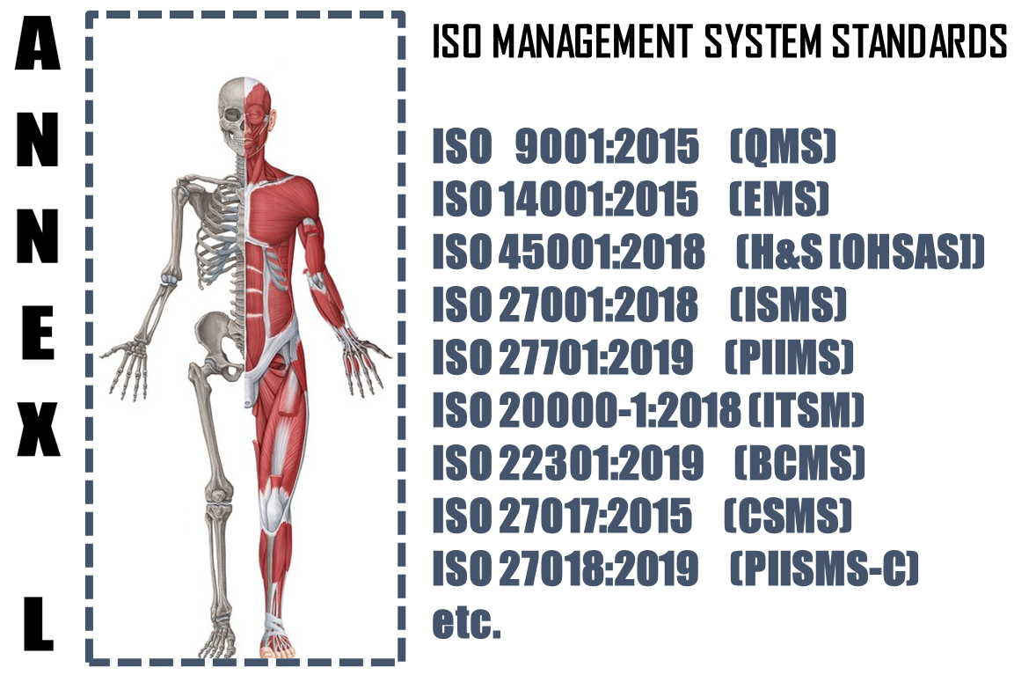

The **Annex L** (now renamed as Annex L in the 2019th edition from Annex SL) is a section of the ISO/IEC Directives part 1 that prescribes how ISO Management System Standard (MSS) standards should be written. The aim of Annex L is to enhance the consistency and alignment of MSS by providing a unifying and agreed-upon high level structure, identical core text and common terms and core definitions. The aim being that all ISO Type A MSS (and B where appropriate) are aligned and the compatibility of these standards is enhanced.

So in short we can say that Annex L is the Skeleton of ISO Management Systems and all standards are now aligned as per Annex L and all the common elements terms and definitions have also been standardized. This has been done to bring in Standard in the Structure, which was not the case in the past, though the intention was the same. So we can say, out of Intent and Content of MS, Content has undergone a change, in the form of Anne L.

What to do in Implementing Business Continuity Management System?

Based on the Scope and Context, following activities have to be performed in logical sequence. These guidelines given below are only basic milestones and a lot of activities may have to be streamlined as per the standard, based on Scope & Context.

|  |  |  |  |  |
| --- | --- | --- | --- | --- |
| **Step #** | **Requirement of BCMS** | **What needs to be done (**C, I & A Separately) | **In what way IRCBO can contribute** | **Tools Recommended** |
| 1 | Defining & Documentation | * Defining & Documenting Scope (Technical [Product/Services] and Territorial Scope (# Locations) where the MS is needed. The Org. Management decides the specific scope in line with Applicable regulations * Defining the External & Interested Parties, their business relationship with Org. (in relevance to scope), Identification of critical processes, Information & Information classification); * Calculation of Risk Appetite & its consideration in BIA & RA * All relevant policies and procedures for delivery of products and services, as per scope & context | IRCBO’s Qualified & Experienced consultants can help you in designing, defining, Implementing, monitoring and Improving the MS.  Note: Our contracts can also be associated after Certification for Maintenance of Management System through our digitized tool contributions – aim is to make any MS a plug and play for most effective Controls & Complying (including Legal Compliances) | IRCBO Tool Kit which includes all solutions for Implementation and backed up by IRCBO Designed Software in cloud for :   * Online training   (including  Induction for new employees, awareness & unlimited Internal Auditor Training & Qualification   * Online Internal Auditing Software – this also includes tracking of corrective actions |
| 2 | Implementation | * Implementing all policies and procedures as per BCMS defined system; * Assigning and plying Responsibilities and Authorities in more transparent manner; * Participating in BIA & Risk Mechanism and approving Residual Risk and Incident investigations – for C, I & A Separately – Finalization of Recovery plans for Normal, Crisis & Disaster situations * Exercising & Testing to Realistic as Possible (RAP); * Maintaining good discipline in demonstrating Leadership and aiming for improvements through Management Review platforms; |
| 3 | Periodical Review | * Monitoring, measuring and performing Analysis to ensure * Considering Internal Audit Findings seriously for Timely Corrective Actions in effective manner and take decisions to improve in Management Reviews |
| 4 | Continual Improvement | Implement all actions of Management Review and aim for Continual Improvement – remember Improvement & Continual Improvement are different Concepts |